

Year 12
ATAR
Human Biology

Name:
ANSWERS
Teacher:

Task 4: Homeostasis Extended Response |  |  | Weighting 5%
Marks Received | Marks Available | Percentage
 | 20

Time Allocated:
Reading time: 5 minutes
Working time: 25 minutes

Homeostasis Extended answer (20 Marks)

This section has one (1) question. You must answer one (1) question. Write your answers on the lined pages provided.

Supplementary pages for the use of planning/continuing your answer to a question have been provided at the end of this Question/Answer booklet. If you use these pages to continue an answer, indicate at the original answer where the answer is continued, i.e. give the page number.

Responses could include clearly labelled diagrams with explanatory notes; lists of points
with linking sentences; clearly labelled tables and graphs; and annotated flow diagrams with
introductory notes.

Suggested working time: 25 minutes.
_________________________________________________________________________

Question 1 (20 marks)

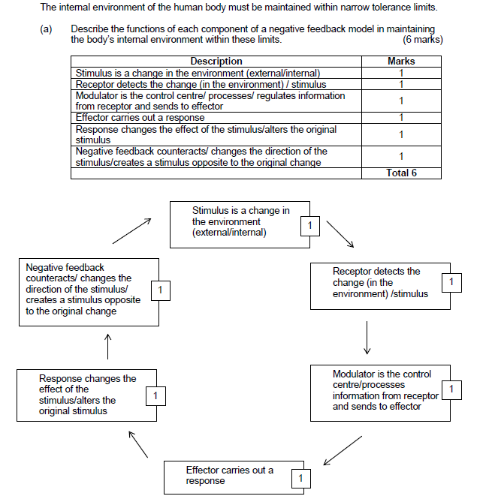
Mark
1
2
3
4
5
6
Total: 6

Description | Mark
- Cerebrum isn’t involved, both controlled by hypothalamus | 1
- Body temperature increases/decreases | 2
- Detected by thermoreceptors in skin/hypothalamus | 3
- Hypothalamus | 4
- Blood vessels in skin: Vasodilation/constriction  - Thyroid gland: releases thyroxin  - Sweat glands: sweat | 5
- Less/more heat loss/production. Body temperature increases/decreases | 6
 | Total: 6

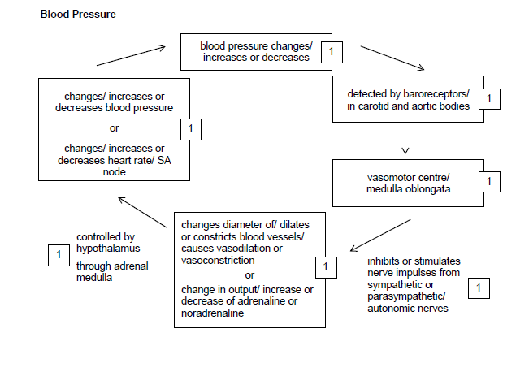
Body temperature
Body temperature changes/
Increases or decreases
Detected by Thermoreceptors in skin/hypothalamus
Blood vessels in skin: Vasodilation/constriction

Thyroid gland: releases thyroxin

Sweat glands: sweat
Increases/decreases heat loss/production

Body temperature increases/decreases

Hypothalamus

Description | Mark
- Osmotic pressure changes/ increases or decreases | 8/ 1
- Detected by osmoreceptors in hypothalamus | 9/ 2
- Hypothalamus | 10/ 3
- Stimulates pituitary gland to releases/stops releasing ADH | 11/ 4
- Kidneys/tubules | 12/ 5
- More/less permeable so more/less water absorbed | 13/ 6
- Changes/ increases or decreases osmotic pressure | 14/ 7
 | Total: 14/ 7

Osmotic Pressure
Osmotic pressure changes/
Increases or decreases
Detected by osmoreceptors in hypothalamus
Hypothalamus
Stimulates pituitary gland to release/stop releasing ADH
Changes how permeable the tubules are so more/less water is absorbed back into the blood
Acted by kidneys/tubules
Changes / increases or decreases osmotic pressure

Increased/decreases water concentration

